Call for Presentations
JpGU-AGU joint meeting 2017 Session A-GE40 on Energy-Environment-Water Nexus and Sustainable Development
Uhttp://www.jpgu.org/meeting_e2017/U

The Japan Geoscience Union (JpGU) Meeting brings together researchers in differing specialties from many institutions throughout the world. It is one of the largest international geoscience events in Asia Oceania region.

The JpGU (Japan Geoscience Union) – AGU (American Geophysical Union) Joint Meeting 2017 will be held on May 20th-25th, 2017 at Makuhari Messe, Chiba, Japan.

The Institute of Rock and Soil Mechanics, Chinese Academy of Sciences (IRSM-CAS) and the National Institute of Advanced Industrial Science and Technology (AIST Japan) launched a new session “Energy-Environment-Water Nexus and Sustainable Development” on this conference in 2017. This session as an international session will include oral presentations, poster presentations, invited lectures and special lectures.

Session Conveners

Ming Zhang, AIST, Japan
Qiang Xue, IRSM-CAS, China
Jet-Chau Wen, YunTech, Taiwan
Ken Kawamoto, Saitama-U., Japan

Welcome your contribution to this session!

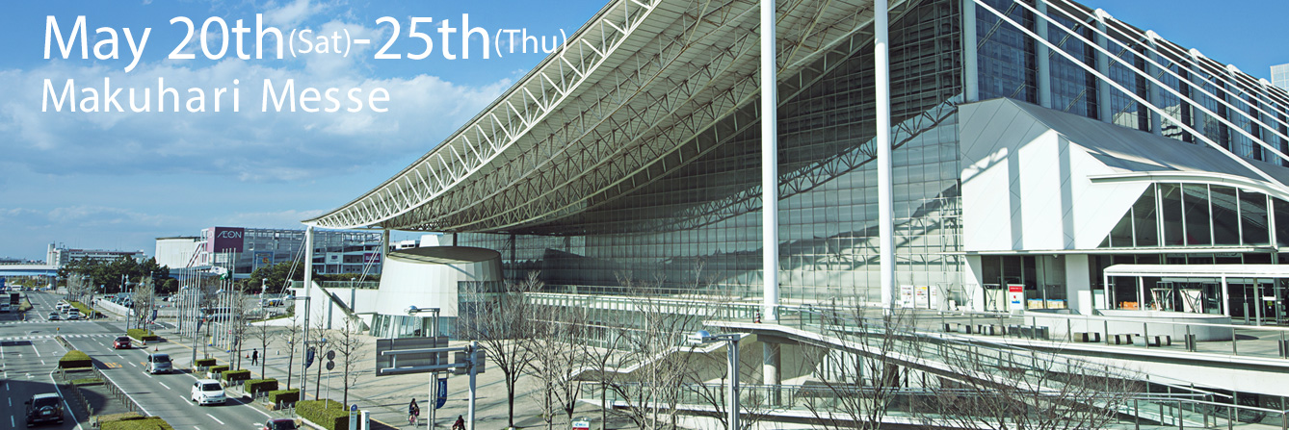

Session Themes include but not limited to the following:

UEnvironment and Sustainable Development
•Waste characterization
•Waste treatment
• Contaminated sites remediation
•Landfill liners and hydraulic barriers
•Gas generation and extraction
•Solid waste management
•Radioactive waste disposal
•Natural attenuation and enhanced bioremediation of organic contaminants
•Novel procedures for characterization of contaminated sites
•Contaminant retardation and degradation processes
•Risk assessment and risk management

UEnergy and Sustainable Development
•Carbon dioxide sequestration
•Carbon dioxide geological utilization
•Geothermal energy
•Shale gas exploitation
•Hydrate
•Acid gas injection
•Compressed air energy storage
•Renewable energy
•Clean energy

UCoupled Processes in Geological Media
•Multi-phase flow
•Biogeochemical processes for improving or stabilizing disposal sites
•Improved understanding of the coupling of any natural and/or anthropogenic
thermo-hydro-mechano-bio-chemical-processes within soils and rocks

Important dates
U6th JAN–16th FEB, 2017 Abstract submission (You can choose Oral or Poster as you like)
8th MAR Acceptance notification
8th MAY Early-bird Registration
11th MAY Release of Abstract PDFs on the web

Best presentation awards
Best presentation awards will be selected in this session to the authors whose works represent novel research with significant real-world applications.

Post-Conference Publications
Selected presenters will be invited to submit original or review paper(s) to a special issue of ASCE (American Society of Civil Engineers) journals or Journal of Rock Mechanics and Geotechnical Engineering (Elsevier).

Location, Transportation and Season Information
The conference site, Makuhari Messe International, is located in the place near to Tokyo, Narita International Airport, Tsukuba city and Tokyo DisneyLand and DisneySea.

Transportations between Tokyo, or Narita International Airport and Makuhari Messe are very convenient.
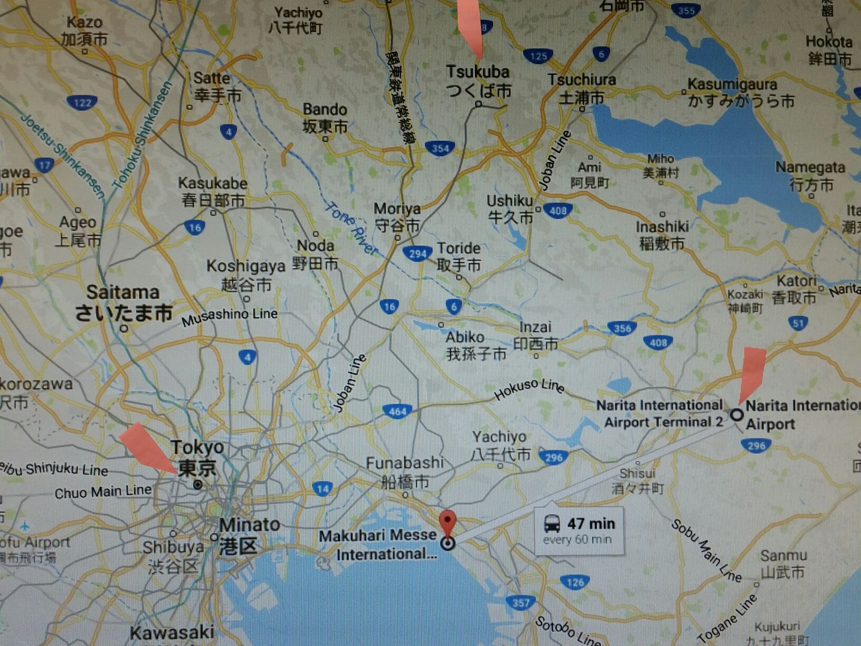
Conference Site
Narita Int’l Airport
National Institute of Advanced Industrial Science and Technology (AIST)
Tokyo Disney

The most convenient way from Narita International Airport Terminal 2 to Makuhari is to take a Narita-Airport Limousine Bus. It just takes less than 1 hour and only costs \900 Yen. Uhttp://www.narita-airport.jp/en/access/bus/U

Trains are also available, but transportation becomes a little bit complicated and takes more time.

May is a very nice season for travelling in Japan. The average temperature in May is 17̊C. Uhttp://www.holiday-weather.com/tokyo/averages/may/U

Contact Us
If you have any special requests or need any assistances, please contact the session secretaries:

Dr. Lei Liu, IRSM-CAS: Ulliu@whrsm.ac.cnU
Phone: 027-8719-8967

Dr. Qi Li, IRSM-CAS: Uqli@whrsm.ac.cnU

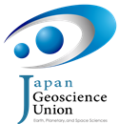

日本地球科学协会与美国地球物理协会 2017年联合大会

《能源-环境-水资源及其可持续发展》分会（A-GE40）

参会回执单

姓名 |  |  |  | 电话
通讯地址
工作单位 |  |  |  |  | 邮编
性别 |  | 职称/职务 |  |  | 邮箱
是否报告? | ○ 口头 | ○ 墙报 |  | ○ 只参会,不报告
报告题目(暂定)
是否有兴趣参加我们会后的英文杂志特辑投稿? |  |  | ○ ASCE Journal of Hazardous, Toxic, and Radioactive Waste (EI)
 |  |  | ○ ASCE Journal of Hydrologic Engineering (IF=1.530)
 |  |  | ○ ASCE International Journal of Geomechanics (IF=1.387)
 |  |  | ○ Journal of Rock Mechanics and Geotechnical Engineering (E-SCI)

联系人：
刘磊 158-71497846 电子邮箱：lliu@whrsm.ac.cn
李琦 159-27123096 电子邮箱：qli@whrsm.ac.cn

